Answers are in blue.

# For Exercises 1–5, match the following numbers with their definition.

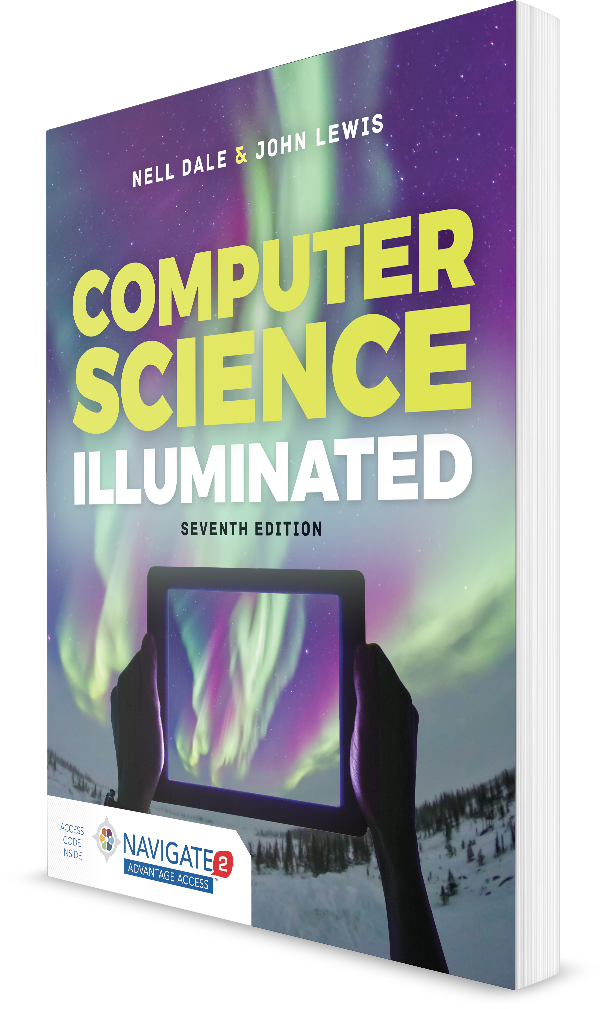

**Computer Science Illuminated, Seventh Edition**

Nell Dale, PhD; John Lewis, PhD

**CHAPTER 2**

EXERCISES AND ANSWERS

1. **Number**
2. **Natural number**
3. **Integer number**
4. **Negative number**
5. **Rational number**
   1. A unit of an abstract mathematical system subject to the laws of arithmetic.

A

* 1. A natural number, a negative of a natural number, or zero. C
  2. The number zero and any number obtained by repeatedly adding one to it.

B

* 1. An integer or the quotient of two integers (division by zero excluded).

E

* 1. A value less than zero, with a sign opposite to its positive counterpart.

D

# For Exercises 6–11, match the solution with the problem.

**A. 10001100**

**B. 10011110**

**C. 1101010**

**D. 1100000**

**E. 1010001**

**F. 1111000**

6. 1110011  11001 (binary addition) A

7. 1010101  10101 (binary addition) C

8. 1111111  11111 (binary addition) B

1. 1111111  111 (binary subtraction) F
2. 1100111  111 (binary subtraction) D
3. 1010110  101 (binary subtraction) E

# For Exercises 12–17, mark the answers true and false as follows:

* 1. **True**
  2. **False**

1. Binary numbers are important in computing because a binary number can be converted into every other base.

B

1. Binary numbers can be read off in hexadecimal but not in octal.

B

1. Starting from left to right, every grouping of four binary digits can be read as one hexadecimal digit.

B

1. A byte is made up of six binary digits. B
2. Two hexadecimal digits can be stored in one byte. A
3. Reading octal digits off as binary produces the same result whether read from right to left or left to right.

A

# Exercises 18–47 are problems or short answer questions.

1. Distinguish between a natural number and a negative number.

A natural number is 0 and any number that can be obtained by repeatedly adding 1 to it. A negative number is less than 0, and opposite in sign to a natural number (although we usually do not consider negative 0).

1. Distinguish between a natural number and a rational number. A rational number is an integer or the quotient of integer numbers. (Division by 0 is excluded.) A natural number is 0 and the positive integers. (See also definitions in answer to Exercises 1–5.)
2. Label the following numbers natural, negative, or rational.

A. 1.333333

rational

B. 1/3

negative, rational

C. 1066

natural

D. 2/5

rational

E. 6.2

rational

1. π (pi)

not any listed

1. If 891 is a number in each of the following bases, how many 1s are there?
   1. base 10 891
   2. base 8

Cannot be a number in base 8

* 1. base 12 1261
  2. base 13 1470
  3. base 16 2193

1. Express 891 as a polynomial in each of the bases in Exercise 21.

A. 8 * 102  9 * 10  1

B. Cannot be shown as a polynomial in base 8.

C. 8 * 122  9 * 12  1

D. 8 * 132  9 * 13  1

E. 8 * 162  9 * 16  1

1. Convert the following numbers from the base shown to base 10.
   1. 111 (base 2) 7
   2. 777 (base 8) 511
   3. FEC (base 16) 4076

D. 777 (base 16)

1911

E. 111 (base 8) 73

1. Explain how base 2 and base 8 are related.

Because 8 is a power of 2, base-8 digits can be read off in binary and three base-2 digits can be read off in octal.

1. Explain how base 8 and base 16 are related. 8 and 16 are both powers of two.
2. Expand the table on page 43 to include the numbers from 11 through 16.

|  |  |  |
| --- | --- | --- |
| *binary* | *octal* | *decimal* |
| 000 | 0 | 0 |
| 001 | 1 | 1 |
| 010 | 2 | 2 |

|  |  |  |
| --- | --- | --- |
| 011 | 3 | 3 |
| 100 | 4 | 4 |
| 101 | 5 | 5 |
| 110 | 6 | 6 |
| 111 | 7 | 7 |
| 1000 | 10 | 8 |
| 1001 | 11 | 9 |
| 1010 | 12 | 10 |
| 1011 | 13 | 11 |
| 1100 | 14 | 12 |
| 1101 | 15 | 13 |
| 1110 | 16 | 14 |
| 1111 | 17 | 15 |
| 10000 | 20 | 16 |

1. Expand the table in Exercise 26 to include hexadecimal numbers.

|  |  |  |  |
| --- | --- | --- | --- |
| *binary* | *octal* | *decimal* | *hexadecimal* |
| 000 | 0 | 0 | 0 |
| 001 | 1 | 1 | 1 |
| 010 | 2 | 2 | 2 |
| 011 | 3 | 3 | 3 |
| 100 | 4 | 4 | 4 |
| 101 | 5 | 5 | 5 |
| 110 | 6 | 6 | 6 |
| 111 | 7 | 7 | 7 |
| 1000 | 10 | 8 | 8 |
| 1001 | 11 | 9 | 9 |
| 1010 | 12 | 10 | A |
| 1011 | 13 | 11 | B |
| 1100 | 14 | 12 | C |
| 1101 | 15 | 13 | D |
| 1110 | 16 | 14 | E |
| 1111 | 17 | 15 | F |
| 10000 | 20 | 16 | 20 |

1. Convert the following binary numbers to octal. A. 111110110

766

B. 1000001

101

C. 10000010

202

D. 1100010

142

1. Convert the following binary numbers to hexadecimal. A. 10101001

A9

B. 11100111 E7

C. 01101110 6E

D. 01111111 7F

1. Convert the following hexadecimal numbers to octal.
   1. A9 251
   2. E7 347
   3. 6E 156
2. Convert the following octal numbers to hexadecimal. A. 777

1FF

B. 605

185

C. 443

123

D. 521

151

E. 1 1

1. Convert the following decimal numbers to octal. A. 901

1605

B. 321

501

C. 1492

2724

D. 1066

2052

E. 2001

3721

1. Convert the following decimal numbers to binary.
   1. 45 101101
   2. 69 1000101

C. 1066

10000101010

1. 99 1100011
2. 1 1
3. Convert the following decimal numbers to hexadecimal. A. 1066

42A

B. 1939

793

C. 1 1

D. 998 3E6

E. 43 2B

1. If you were going to represent numbers in base 18, what symbols might you use to represent the decimal numbers 10 through 17 other than letters?

You could extend the hexadecimal approach and use G for 16 and H for 17. But any special characters would work or characters from another alphabet, so you could use # for 16 and @ for 17, for instance.

1. Convert the following decimal numbers to base 18 using the symbols you suggested in Exercise 35.

A. 1066

354 (answers will vary)

B. 99099

#@F9 (answers will vary)

C. 1

1 (answers will vary)

1. Perform the following octal additions. A. 770  665

1655

B. 101  707

1010

C. 202  667

1071

1. Perform the following hexadecimal additions. A. 19AB6  43

19AF9

1. AE9  F AF8
2. 1066  ABCD BC33
3. Perform the following octal subtractions. A. 1066  776

70

B. 1234  765

247

C. 7766  5544

2222

1. Perform the following hexadecimal subtractions.
   1. ABC  111 9AB

B. 9988  AB 98DD

C. A9F8  1492 9566

1. Why are binary numbers important in computing?

Data and instructions are represented in binary inside the computer.

1. A byte contains how many bits? 8
2. How many bytes are there in a 64-bit machine? 8
3. Why do microprocessors such as pagers have only 8-bit machines?

Pagers are not general-purpose computers. The programs in pagers are small enough to be represented in 8-bit machines.

1. Why is important to study how to manipulate fixed-sized numbers?

It is important to understand how to manipulate fixed-sized numbers because numbers are represented in a computer in fixed-sized format.

1. How many ones are there in the number AB98 in base 13? ((13 * 13 * 13 * 10)  (13 * 13 * 11)  13 * 9)  8)  23954
2. Describe how a bi-quinary number representation works. There are seven lights to represent ten numbers. The first two determine the meaning of the next five. If the first light is on, the next five represent 0, 1, 2, 3, and 4, respectively. If the second is on, the next five represent 5, 6, 7, 8, and 9, respectively.